

## Test Two

## Semester One 2017 UNIT 1 METHODS

## Calculator Assumed 15 minutes /20 marks

## Scientific Calculator, ClassPad, Formula Sheet and One page one side of A4 notes is permitted

**Name:**

Place a tick in the box next to your Mathematics teachers name:

|  |  |
| --- | --- |
| **Mr Strain** | **□** |
| **Ms Sindel** | **□** |
| **Ms Rimando** | **□** |
| **Ms Reynolds** | **□** |
| **Dr Pearce** | **□** |
| **Mrs Flynn** | **□** |
| **Ms Ensly** | **□** |
| **Mrs Carter** | **□** |

**Question 8 (2, 2 = 4 marks)**

State the domain and range

1. (-3, 2), (2, 1), (0, 0), (1, 5), (4, -7), (2, 5)
2. 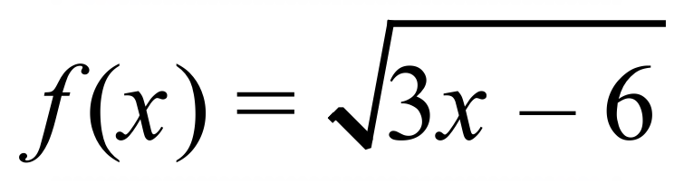

**Question 9 (3 marks)**

Demonstrate how to complete the square for 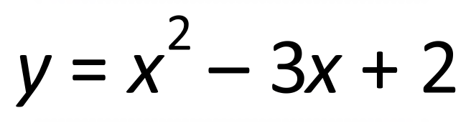. Then state the turning point.

**Question 10 (4 marks)**

Calculate the shortest distance between the parallel lines 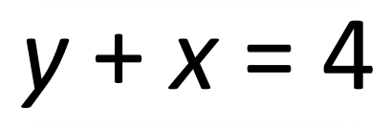 and 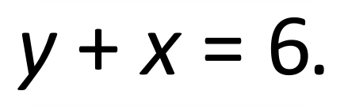 Leave your answer in exact form.

**Question 11 (1, 1, 2 = 4 marks)**

A ramp walkway is to be built over a ravine. It is to be attached to a supporting cable as shown in the diagram. Both the ramp walkway and supporting cable are in the shape of a quadratic function.

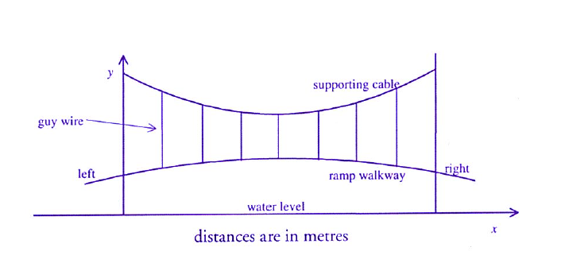

The equation of the ramp walkway is 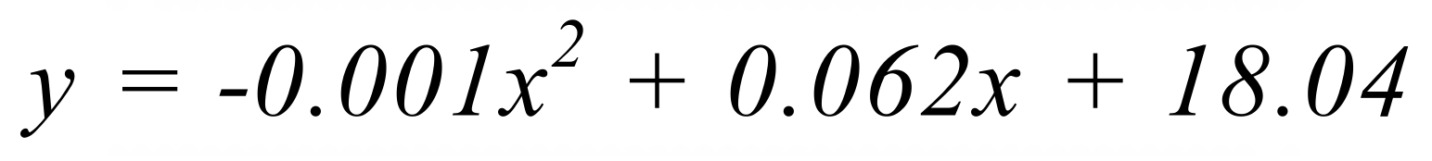

The equation of the supporting cable is 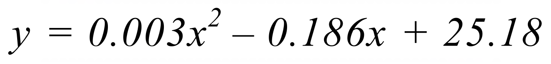

a) Find the length of the shortest guy wire.

b) What is the closest the ramp walkway is to the water surface?

c) How far from the left end is the supporting cable 24m above the water?

**Question 12 (5 marks)**

Sketch the graph of 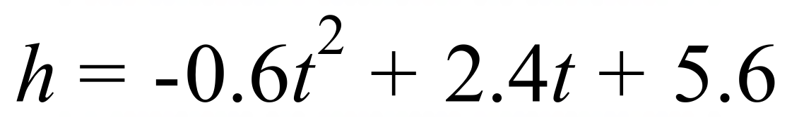 ,indicate the major features.

